Exhibit A: Kidder Creek Orchard Camp Zone Change and Use Permit Project (Z-14-01 and UP-11-15)
APN: 025-370-380

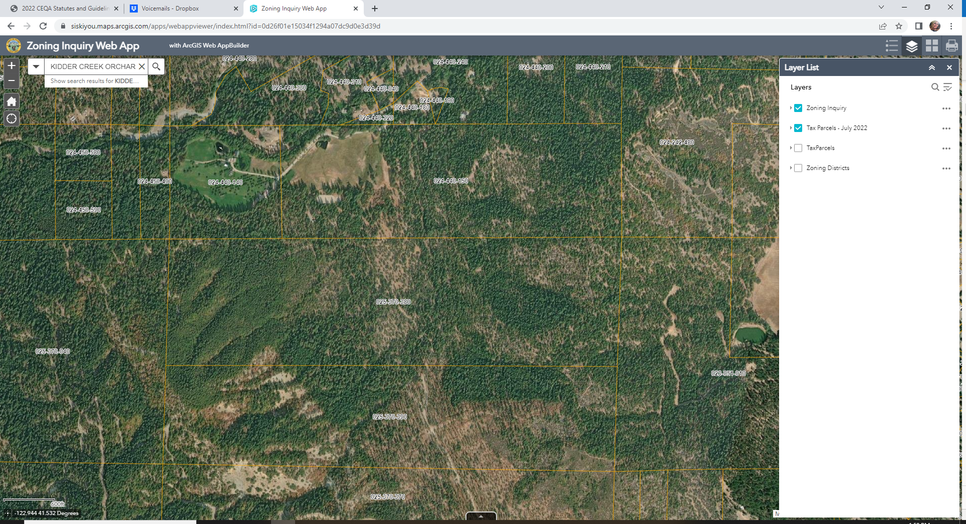
RR
TPZ

